|  |  |
| --- | --- |
| Student ID | IT22341204 |
| Batch | Group - Y2.S2.WE.IT.02.01 |
| Name | K Rangana Malmi Nadee |
| Marks |  |
| 1. Ideation (2 Marks) |  |
| 1. Applying “60-30-10 rule” when deciding the colors. (2 Marks) |  |
| 1. Selecting suitable layouts (2 Marks) |  |
| 1. Using proper views for the user interface (2 Marks) |  |
| 1. Creativity (1 Mark) |  |
| Total: 10 Marks |  |
| Evaluator |  |

**Description:**

**Home Heaven Rent App**

**Rent Home ,Apartments and Condominiums**

Home Heaven Rental App is a user-friendly platform that connects property owners with interested renters. It provides a comprehensive range of rental units, such as apartments, houses, and condominiums, to meet a variety of needs and tastes.

**User Profiles**: Users can create profiles specifying their preferences, budget, and desired location for renting a property.

**Property Listings**: Property owners can list their available rentals, including detailed descriptions, high-quality images, and pricing information. They can also specify rental terms, such as lease duration and pet policies.

**Booking and Scheduling**: Renters can book property viewings directly through the app, making the scheduling process easier for both parties. The app allows property owners to arrange viewing appointments and connect with potential renters.

**Customer Support**: The app offers dedicated customer support channels to quickly handle any problems, concerns, or technical issues.

Home Heaven Rental App differentiates itself from typical rental platforms by providing extensive features that cater to the changing needs of both renters and property owners during economic crises. The app's goal is to build a trustworthy community of tenants and landlords looking for mutually beneficial rental agreements by allowing simple transactions, promoting transparency, and prioritizing user satisfaction.

To summarize, the Home Heaven Rental App is a convenient one-stop solution for people navigating the rental market during times of economic uncertainty, promoting efficiency, dependability, and peace of mind throughout the renting process.

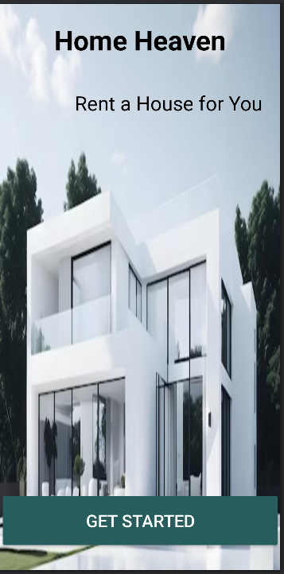**Screenshots:**

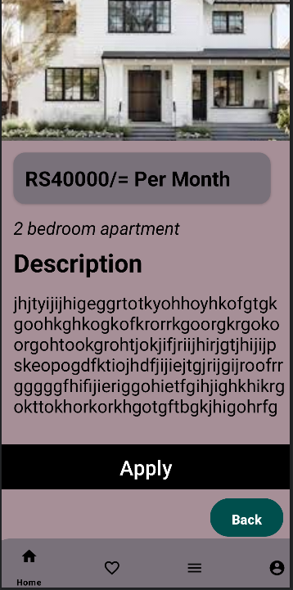

**Content of xml files of Strings and Colors:**

**Strings**

**Colors**

